**OOP WS27 EXAM REVIEW Q71-100**

**DATE: 20th december 2022**

0 EDISON LASCANO 5 + 4 +7.5 = 16.5/20

Inspector: Jorge Lascano

Feature: CREATE

MongoDB Database: /5

Diseño GUI /5

Working application /10 (Screen+MongoDb Atlas)

Mistaken Working application /7.5 (Screen + MongoDB Atlas)

14 CORREA RUIZ KERLY YADIRA

Inspector:Darling Cruz

MongoDB Database: 5/5

Diseño GUI 5/5

Working application 0//10 (Screen+MongoDb Atlas)

Wrong Working application 0/7.5 (Screen + MongoDB Atlas)

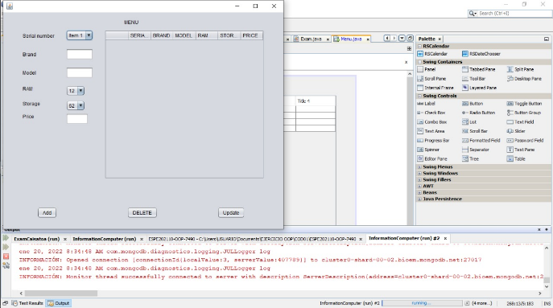

15 CRUZ PANTOJA DARLING MICAELA

Inspector: Alejandro De La Cruz

Feature: CREATE

MongoDB Database: 5/5

Diseño GUI 0/5

Working application 2/10 (Screen+MongoDb Atlas)

